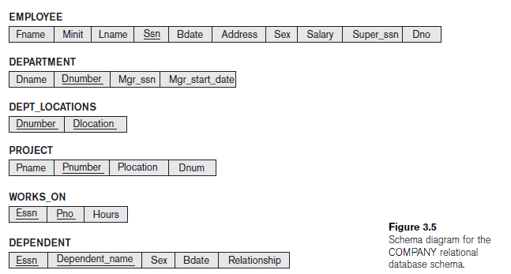

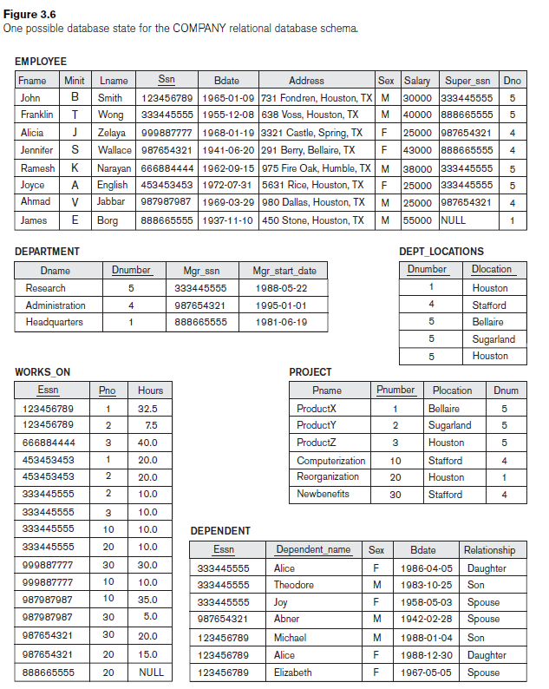

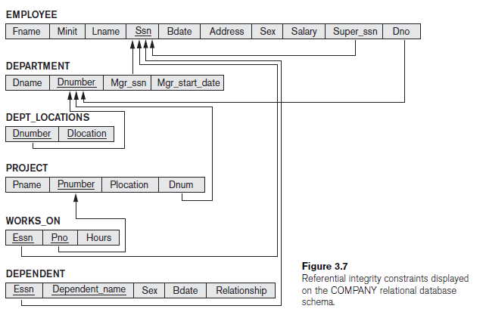

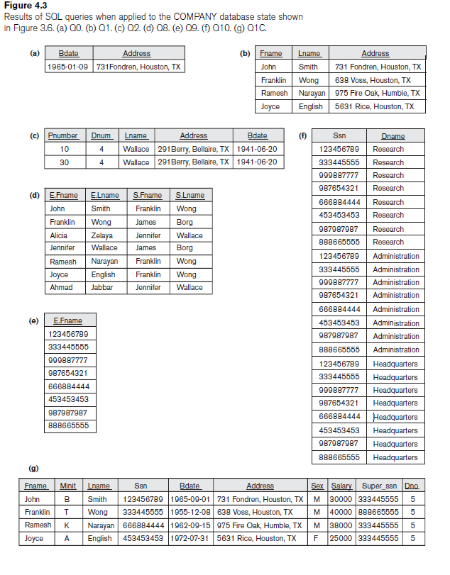

1. **Query .** Retrieve the birth date and address of the employee(s) whose name is ‘John B. Smith’.
2. **Query .** Retrieve the name and address of all employees who work for the

‘Research’ department.

1. **Query:** For every project located in ‘Stafford’, list the project number, the controlling department number, and the department manager’s last name, address, and birth date.
2. **Query:** For each employee, retrieve the employee’s first and last name and the first and last name of his or her immediate supervisor.
3. **Query:** Write a query which is retrieves all the attribute values of any EMPLOYE who works in DEPARTMENT number 5
4. **Query:** write a query which is retrieves all the attributes of an EMPLOYEE and attributes of the DEPARTMENT in which he or she works for every employee of the ‘Research’ department,
5. **Query:** write a query which is specifies the CROSS PRODUCT of the EMPLOYEE and DEPARTMENT relations.
6. **Query:** Select all EMPLOYEE Ssns in the database.
7. **Query**: Select all EMPLOYEE Ssns
8. **Query:** Retrieve the salary of every employee .
9. **Query:** Retrieve the all distinct salary value.
10. **Query:** Make a list of all project numbers for projects that involve an employee whose last name is ‘Smith’, either as a worker or as a manager of the department that controls the project.
11. **Query:** Retrieve all employees whose address is in Houston, Texas.
12. **Query:** Find allemployees who were born during the 1950s.
13. **Query:** Show the resulting salaries if every employee working on the ‘ProductX’ project is given a 10 percent raise.
14. **Query:** Retrieve all employees in department 5 whose salary is between $30,000 and $40,000.
15. **Query:** Retrieve a list of employees and the projects they are working on, ordered by department and within each department, ordered alphabetically by last name, then first name.
16. **Query:** Retrieve the name of all employees who do not have supervisors.
17. **Query:** Retrieve the name of each employee who has a dependent with the same first name and is the same sex as the employee.
18. **Query:** write a query which is retrieve In general, a query written with nested select-from-where blocks and using the = or IN comparison operators can always be expressed as a single block query.
19. **Query:** Retrieve the names of employee who have no dependents.
20. **Query:** List the name of managers who have at least one dependent.

1. **Query:** Retrieve the Social Security numbers of all employee who work on project numbers 1, 2, or 3.
2. **Query:** Find the sum of the salaries of all employees, the maximum salary, the minimum salary, and the average salary.
3. **Query:** Find the sum of the salaries of all employees of the ‘Research’ department, as well as the maximum salary, the minimum salary, and the average salary in this department.
4. **Query:** Retrieve the total number of employees in the company.
5. **Query:** Retrieve the total number of employees in the company and the number of employees in the ‘Research’ department.
6. **Query:** Count the number of distinct salary value in the database.
7. **Query:** For each department, retrieve the department number, the number of employees in the department, and their average salary.
8. **Query:** For each project, retrieve the project number, the project name, and

the number of employees who work on that project.

1. **Query:** For each project *on which more than two employees work,* retrieve the project number, the project name, and the number of employees who work on the project.
2. **Query:** For each project, retrieve the project number, the project name, and

the number of employees from department 5 who work on the project.

1. **Query:** For each department that has more than five employees, retrieve the department number and the number of its employees who are making more than $40,000.